An Integrated Class Record Management System for the CCA Portal: Streamlining Academic Data and Performance Tracking

A Thesis Presented to the Faculty of
Institute of Computing Studies and Library Information Science
City College of Angeles
Angeles City



In Partial Fulfillment of the Requirement for the Degree
Bachelor of Science in Computer Science

By:
Acopio. Ross Jhem
Cacatian. Kurt Russel
Dela Cruz. John Edson
Ricci Neil G. Zapanta

January 2025

APPROVAL SHEET
This Thesis entitled “An Integrated Class Record Management System for the CCA Portal: Streamlining Academic Data and Performance Tracking” prepared and submitted by:

Acopio. Ross Jhem
Cacatian. Kurt Russel
Dela Cruz. John Edson
Ricci Neil G. Zapanta

In partial fulfillment of the requirements for the degree Bachelor of Science in Computer Science, has been examined and is recommended for acceptance and approval for Oral Examination.

Ms. Jannette G. Zapata |  | Insert Name Here
Thesis Instructor |  | Adviser

THESIS COMMITTEE
After having been presented is hereby accepted by the Committee on Oral Examination towards the fulfillment of the requirements for the Degree of Bachelor of Science in Computer Science.

Insert Name Here
Chairman
Insert Name Here |  | Insert Name Here
Member |  | Member

Noted by:

Insert Name Here |  | Insert Name Here
Program Coordinator, BSCS |  | Dean, ICSLIS

TABLE OF CONTENTS
APPROVAL SHEET ii
ACKNOWLEDGEMENT iii
TABLE OF CONTENTS iv
LIST OF TABLES vi
LIST OF FIGURES vii
ABSTRACT 1
INTRODUCTION 2
Background of the Study 2
Statement of the Problem 3
Objectives of the Study 3
Scope of the Study 4
Delimitations of the Study 4
Conceptual Framework / Theoretical Framework / Paradigm of the Study 5
Significance of the Study 5
Definition of Terms 6
METHODOLOGY 7
Algorithm 7
Research Design 7
System Development Methodology 7
Participants 8
Procedure 8
Data Analysis 8
Design and Implementation 9
Requirement Specification Analysis 9
System Design and Specifications 9
Logical Specifications 9
Hardware Specifications 10
Software Specifications 10
RESULTS 11
System / Application Outputs 11
Evaluation Results 11
DISCUSSION 12
Summary of Findings 12
Conclusions 12
Recommendations 12
REFERENCES 13
APPENDICES 14
Appendix A: Caption 14

INTRODUCTION

Background of the Study
In the contemporary educational landscape, the efficient management of academic records has become essential for improving institutional effectiveness. The shift from traditional paper-based systems to digital solutions has paved the way for more accurate, accessible, and secure data management processes. Class record management systems have emerged as a vital tool in higher education, enabling educators to track student performance systematically while enhancing administrative efficiency. Smith and Johnson (2023) highlight the growing adoption of lass record management systems in higher education institutions and emphasize their role in streamlining data management processes and ensuring real-time access to academic records.
The importance of academic data management has been underscored by numerous studies. Brown and Patel (2021) stress that implementing strategic data management practices can significantly improve institutional efficiency and student learning outcomes. By leveraging digital tools, educational institutions can maintain organized records, reduce errors, and enhance decision-making processes related to student performance tracking and curriculum development.
In the realm of K-12 education, Harris and Roberts (2022) provide an extensive review of technological and pedagogical approaches to performance tracking. Their study suggests that the integration of technology into academic tracking systems fosters personalized learning experiences and supports data-driven decision-making. This highlights the necessity for educational institutions to adopt advanced Class record management systems that facilitate early identification of learning gaps and ensure timely interventions.
Nguyen and Tran (2021) explore the potential of real-time academic performance tracking through enhanced student information systems. They argue that integrating artificial intelligence and predictive analytics into class record management systems can revolutionize the way educational institutions monitor student progress. By offering data-driven insights, institutions can proactively support students, helping to reduce dropout rates and promote academic success.
Higher education institutions have increasingly turned to online academic portals to facilitate seamless academic record management. Lee and Chan (2022) discuss both the opportunities and challenges associated with the integration of online academic portals. While these portals offer improved accessibility and security, they require substantial investments in infrastructure and faculty training to ensure successful implementation. However, the long-term benefits, including efficient data retrieval and enhanced student engagement, outweigh the initial challenges.
The integration of learning management systems with student performance tracking has also gained traction in recent years. Williams and Foster (2021) examine how learning management systems integration enhances the functionality of Class record management systems, enabling educators to obtain a comprehensive view of student engagement and progress. Their findings indicate that institutions that successfully integrate learning management systems with Class record management systems can offer personalized learning experiences while optimizing administrative processes.
Morris and Chang (2023) provide a systematic review of the role of educational technologies in tracking student academic performance. Their study emphasizes the increasing reliance on digital tools to manage academic records efficiently. They argue that as technology continues to evolve, institutions must remain adaptable to new innovations to ensure that their Class record management systems remain effective and relevant in modern learning environments.
The transition to an integrated class record management system is particularly significant for the City College of Angeles Portal, where academic data management and performance tracking are central to institutional operations. Implementing an advanced Class record management systems at City College of Angeles will enhance the efficiency of record-keeping processes, reduce administrative workload, and improve communication between students and faculty through real-time data updates.
Moreover, an integrated Class record management systems will provide educators with data-driven insights that can be used to personalize instructional strategies and improve student engagement. This aligns with broader trends in educational technology, where institutions leverage digital solutions to enhance learning experiences and improve institutional effectiveness.
Additionally, digital Class record management systems ensure data accuracy and security, reducing the risks associated with manual record-keeping errors. Institutions that implement advanced Class record management systems benefit from improved compliance with educational regulations, streamlined reporting processes, and enhanced collaboration between faculty members.
Despite the clear benefits, the adoption of Class record management systems requires careful planning, infrastructure investments, and faculty training. Addressing these challenges proactively will ensure a smooth transition and maximize the potential of these systems in improving academic record management.
In conclusion, the implementation of an integrated Class record management systems is a critical step in optimizing academic data management and performance tracking. The studies reviewed highlight the transformative potential of digital solutions in education, emphasizing the importance of adopting advanced Class record management systems to enhance institutional efficiency and student success. As educational institutions continue to embrace technological innovations, the integration of Class record management systems will play a crucial role in shaping the future of academic record management.

Statement of the Problem
The current systems used for managing class records, attendance, and academic performance in educational institutions often face significant challenges that hinder effective academic tracking and communication. Faculty members and administrative staff encounter inefficiencies in manually managing and updating academic data, leading to the following issues:
- The current class record management system often requires manual entry of class schedules and student enrollment details, which increases the likelihood of errors and delays in accessing important academic data.
- The existing system does not allow for automated tracking of student absences, nor does it provide an effective mechanism for students to submit excused absences and for faculty to approve them in a transparent manner.
- The current system lacks comprehensive tracking of students' grades and academic performance throughout the semester.
- The current system does not have effective tools for communication between faculty, students, and administrators.
- The existing system provides limited options for data visualization and analysis, making it difficult to understand patterns and trends in academic performance.

Objectives of the Study
The primary goal of this study is to design and implement an integrated Class Record Management System for the CCA Portal that will address the current limitations and streamline academic data management. The specific objectives are as follows:
- To Develop an Automated System for Importing Class Schedules and Student Data.
- To Improve Attendance and Absence Management.
- To Enhance Grade and Performance Tracking Capabilities.
- To Streamline Communication and Reporting Features.
- To Incorporate Data Visualization and Ensure Cross-Platform Access.

Scope of the Study
This study focuses on the development of an integrated class record management system for the CCA Portal, aimed at streamlining the management of academic data and performance tracking. The scope of this study includes the creation of a comprehensive system that automates key administrative and academic functions, enhancing both efficiency and accuracy. The system will be designed for use by faculty, students, registrars, and academic administrators such as program coordinators and deans. This study will cover the design, implementation, and evaluation of the system, ensuring that it meets the needs of all stakeholders involved in managing class records, attendance, performance, and communication.
The system will be capable of importing class schedules and enrolled student data directly into the CCA Portal, ensuring accurate and up-to-date information. It will facilitate the creation of detailed class records for each course offered in a given semester, as well as for previous semesters. These class records will include essential information such as class schedules, student attendance, raw scores, and final grades. The system will also track student absences, enabling faculty to approve or reject excuse requests and provide necessary feedback on absences and missed activities. Additionally, students will have the ability to upload excuse letters, which will be visible to faculty, program coordinators, and the dean, ensuring transparency and accountability.
Another critical feature of the system will be the integration of grade entry and computation. Faculty will be able to input raw scores through manual encoding or import options, with an automatic timestamp for every entry. The system will track any changes to scores and maintain a history log for accountability. Computation of grades will be automated based on the grading system used by CCA, and summaries will be generated to show the status of students, such as passed, failed, or officially dropped (UW, LOA, OD). This functionality will allow for efficient management of student grades and minimize errors caused by manual calculations.
In addition to these features, the system will also include tools for communication between faculty, students, and academic administrators. Faculty will be able to send notifications regarding absences, grades, and missing activities to students, ensuring that students are informed about their academic status. The system will also allow faculty to communicate with program coordinators and deans for approval of student requests, such as excused absences and changes in enrollment status.
The system will be designed to integrate with other institutional systems and allow for easy retrieval of midterm and final grades without the need for manual encoding. It will also offer a mobile access feature, allowing stakeholders to access and update student data on the go. The study will also explore the use of data visualization tools.
In conclusion, the implementation of an integrated Class record management systems is a critical step in optimizing academic data management and performance tracking. The studies reviewed highlight the transformative potential of digital solutions in education, emphasizing the importance of adopting advanced Class record management systems to enhance institutional efficiency and student success. As educational institutions continue to embrace technological innovations, the integration of Class record management systems will play a crucial role in shaping the future of academic record management.

Delimitations of the Study
This study is limited to the design and implementation of an integrated class record management system for the CCA Portal, focusing specifically on academic data related to class records, attendance, grades, and student performance tracking. While the system will allow for some integration with other institutional systems, the scope of integration will be limited to academic and performance-related data, and will not extend to administrative functions outside of the academic domain, such as financial records or student health data.
The study will primarily focus on the academic needs of faculty, students, and academic administrators (registrars, program coordinators, and deans) within CCA institutions. The system will not be designed for use in non-CCA institutions or for non-academic purposes. Furthermore, the system will not directly address issues related to student registration processes or student support services, although it will provide some communication tools for coordination with academic administrators regarding student absences and performance concerns.
The system's features related to student performance tracking will be tailored to align with the grading policies and practices of CCA, which may vary across different academic disciplines and departments. As such, the system's grading and reporting features will be designed to accommodate different grading systems, but the study will not cover the development of a standardized grading system that could be applied to all institutions.
While the system will include mobile access, it will be limited to basic functions such as viewing grades, attendance records, and class schedules. The study will not address the full scope of mobile app development or the creation of a mobile version of the portal that includes all the features available on the desktop version.
While the study will include data visualization tools for performance analysis, the scope of this feature will be limited to visual representations of student performance data such as grades, attendance patterns, and performance summaries. It will not delve into more advanced forms of data analytics or predictive modeling, nor will it include the development of personalized reports based on individual student needs beyond basic academic performance tracking.
The study’s scope is focused on the design and implementation of a user-friendly class record management system for the CCA Portal that automates and streamlines academic data handling, with a primary focus on class schedules, student performance, attendance, grades, and communication among stakeholders. The delimitation of the study ensures that the system remains within the boundaries of academic management, excluding non-academic and highly specialized features

Conceptual Framework
INPUT
Researchers Requirements:
- Group Discussion
- Brainstorming
- Process Plan
Procedure and Data Gathering(Data Analysis)
- Survey(Before the software)
- Interview(Before the software)
- Evaluation(After the software)
User Requirements:
Faculty Members
- Import class schedule and enrolled students
- Create and manage class records for current and previous semesters
- Track student attendance with absence notifications
- Enter, update, and compute grades
- Generate deliberation reports
- Identify top-performing students per term
Registrar
- Manage master list of enrolled students
- Update student enrollment status (UW, LOA, OD, etc.)
- Generate summary reports
Dean/Program Coordinator
- Approve student excuse letters
- View list of officially dropped students
- Access deliberation summaries
Students
- View attendance and absence status
- Upload excuse letters for approval
- Access grades for transparency
System Requirements:
- Data import and integration with CCA Portal
- Attendance tracking with FA status monitoring
- Score entry with manual and import options
- Grade computation and history logging
- Communication features for student engagement
- Seat plan arrangement (manual and automatic)
- Midterm and final grades fetching from class records
- Compliance with CCA grading systems
- Data visualization and performance tracking
- Search and filter functions
- Mobile accessibility
- Report generation conforming to institutional templates

An Integrated Class Record Management System for the CCA Portal: Streamlining Academic Data and Performance Tracking

PROCESS

Data Gathering

Initial Planning Phase

- Conduct Group Discussions among researchers to define objectives, scope, and key features of the system.
- Perform Brainstorming Sessions to generate ideas, identify potential challenges, and propose solutions.
- Develop a Process Plan to outline research methodology, timeline, and expected deliverables.

Pre-Implementation Data Gathering
- Conduct a Survey among faculty, students, and administrators to understand current challenges in class record management.
- Hold Interviews with key stakeholders (faculty, registrar, dean, students) to gather qualitative insights and specific requirements.
Data Processing & Management
- Import and organize class schedules and enrolled students
- Create class records for faculty accounts
- Automate attendance tracking with notifications
- Enable excuse letter submission and approval workflow
- Facilitate raw score entry and grade computation
- Generate real-time academic performance reports
Workflow Automation
- Registrar updates student status, reflected in all class records
- Dean and program coordinators approve excused absences
- Automatic fetching of midterm and final grades from records
- Communication features for missing activities and incentives
Agile Development Methodology
- Plan: Define requirements and design system architecture
- Design: Create user interface and database structures
- Develop: Implement core functionalities and integrations
- Test: Validate features with faculty, students, and administrators
- Deploy: Launch system within the CCA Portal
Review: Gather feedback and make iterative improvements

On the process in the conceptual framework, The Integrated Class Record Management System for the CCA Portal is designed to streamline academic data management and performance tracking by automating key processes for faculty, students, and administrators. The input phase involves gathering requirements through group discussions, brainstorming, surveys, and interviews to identify challenges in managing class records, attendance, and grading. The process includes developing a system that automates data import, attendance tracking, grade computation, and communication, ensuring seamless integration with the CCA Portal. Workflow automation allows real-time updates on student performance, faculty interventions, and registrar approvals for enrollment status changes. Finally, the output delivers a transparent, efficient, and accessible system where faculty can manage records with ease, students can track their academic progress in real-time, and administrators can generate standardized reports, ultimately enhancing institutional efficiency and compliance with CCA grading policies.
Significance of the Study

- To the Administrator, this study offers a significant advancement in streamlining administrative tasks related to academic data management.
- To the School, this study is valuable as it supports the institution’s goals of enhancing operational efficiency, improving student outcomes, and ensuring transparency
- To the Teachers, the study offers a tool that simplifies the process of managing class records, tracking attendance, entering raw scores, and computing grades.
- To the Students, this study is significant as it offers a transparent and efficient platform to track their academic progress in real-time. Through the integrated class record management system, students will have easy access to their attendance, grades, and overall performance.
- To the Researcher, this study serves as a foundation for exploring the integration of technology in academic data management.
- To the Future Researcher, this study provides a model for future investigations into the impact of integrated systems in educational settings.

Definition of Terms
Import Class Schedule and Enrolled Students in CCA Portal: This feature allows for the automatic importing of class schedules and enrolled students into the system, ensuring accurate and up-to-date information.
Creation of Class Records: Facilitates the generation of class records for all courses in a faculty's account, including details of the current and previous semesters, streamlining record-keeping.
Class Records Include:
- Schedule of Class: Displays the class timetable for easy reference.
- Attendance Sheet: Tracks student absences, notifies students when they're approaching FA status, and allows for excuse submission and approval by faculty, coordinators, and deans.
- Raw Score Entry: Allows manual or imported score entries, with automatic date logging, a score history log, grade computation, and a summary of student statuses (e.g., passed, failed, LOA).
- Deliberation Form: Consolidates all student performance issues and intervention actions into one report.
- Top 10 Students per Term: Highlights the top-performing students based on their grades.
Registrar Features: Enables the registrar to manage student enrollment status, update records, and provide summary reports while deactivating students who change status (e.g., UW, LOA).
Dean/Program Coordinator Features: Allows the dean or coordinator to view dropped students, approve excused absences, and access deliberation reports related to students' performance.
Communication Features: Provides communication tools to notify students about excused absences, missing activities, and incentives, ensuring effective interaction between faculty and students.
Seat Plan: Allows the creation of a seat plan for classrooms, either manually or automatically, based on student names (alphabetically or shuffled).
Grade Visibility: Ensures transparency by making students' grades visible in their accounts, allowing them to track their academic progress.
Midterm and Final Grades Fetching: Automatically fetches midterm and final grades from class records, removing the need for manual input in the system.
Use of Grading System: Adapts to different grading systems used by various institutes and courses, providing flexibility for diverse academic structures.
Data Visualization: Incorporates data visualization features to help users analyze academic data more effectively (as per recommendation).
Search and Filter Functions: Enables users to search and filter records quickly based on various criteria for ease of use.
Mobile Access: Ensures that the system is accessible through mobile devices, allowing faculty, students, and administrators to manage academic data on the go.
Integration with Other Systems: Provides integration capabilities with other academic or administrative systems, ensuring smooth data flow and reducing redundancy.
Report Templates Compliance: Ensures that all generated reports adhere to the standardized templates used by the institution, ensuring consistency.
Recommendations Updating: Allows faculty and administrators to modify or update recommendations until the pre-oral defense stage, ensuring flexibility in the evaluation process.

REVIEW OF RELATED LITERATURE AND STUDIES

Foreign RRL
- Enhancing Student Performance Through Integrated Learning Analytics Dashboards
Abstract
This study explores the design and implementation of integrated learning analytics dashboards in higher education. It examines how real-time data visualization can improve student engagement and academic outcomes. The study analyzes the benefits of combining data from various sources, including LMS platforms, student information systems, and assessment tools."
Synthesis
The integration of learning analytics dashboards is crucial for enhancing student performance. Research suggests that these dashboards provide real-time insights, enabling students and educators to make data-driven decisions. Integrating data from multiple sources allows for a comprehensive view of student progress.

DOI: 10.5281/zenodo.7500860
Link: https://ijaeti.com/index.php/Journal/article/view/631

- API-Driven Data Integration for Educational Portals: Best Practices
Abstract
This review examines best practices for using APIs to integrate diverse educational data sources into centralized portals. It discusses the challenges and solutions related to data interoperability, security, and scalability. The paper presents case studies of successful API integrations in educational settings.
Synthesis
Effective data integration through APIs is essential for creating robust educational portals. Research highlights best practices for ensuring data interoperability, security, and scalability. Case studies demonstrate the successful implementation of API-driven integrations in various educational contexts.
DOI: 10.5281/zenodo.7500860
Link: https://ijaeti.com/index.php/Journal/article/view/631

- Cloud-Based Data Security for Academic Performance Tracking Systems
Abstract
This study investigates the security and privacy implications of storing academic performance data in cloud environments. It analyzes the vulnerabilities of cloud-based systems and proposes security measures to protect sensitive student information. The paper also discusses compliance with data protection regulations.
Synthesis
Data security in cloud-based academic systems is a critical concern. Research emphasizes the need to address vulnerabilities and implement robust security measures to protect student information. Compliance with data protection regulations is also essential.
DOI: 10.5281/zenodo.7500860
Link: https://ijaeti.com/index.php/Journal/article/view/631

- Mobile-First Design for Student Academic Portals: User Experience
Abstract
This research explores the user experience of mobile-first student academic portals. It examines the design principles and usability factors that contribute to effective mobile access to academic information. The study evaluates the impact of mobile portal design on student engagement and satisfaction.
Synthesis
Mobile-first design is crucial for enhancing the user experience of student academic portals. Research highlights the importance of usability factors and design principles that contribute to effective mobile access. Improved mobile access leads to increased student engagement and satisfaction.
DOI: 10.48550/arXiv.2202.02915
Link:https://www.researchgate.net/publication/358422504_Mobile_Based_Gradebook_with_Student_Outcomes_Analytics

- The Role of AI in Automated Gradebook Systems"
Abstract
This paper explores the role of artificial intelligence (AI) inautomating gradebook systems. It examines how AI can be used to provide personalized feedback, identify at-risk students, and streamline grading processes. The paper discusses the benefits and challenges of implementing AI-powered gradebook systems.
Synthesis
AI plays a significant role in automating gradebook systems. Research indicates that AI can provide personalized feedback, identify at-risk students, and streamline grading processes. However, challenges related to implementation and ethical considerations must be addressed.
DOI: 10.1186/s41239-022-00372-4
Link:https://educationaltechnologyjournal.springeropen.com/articles/10.1186/s41239-022-00372-4

Foreign RRS
- A Study on the Impact of Real-Time Performance Dashboards on Student Engagement
Abstract
This study investigates the impact of real-time performance dashboards on student engagement in online courses. The research analyzes data from a controlled experiment involving students using an LMS with a performance dashboard. Results indicate a significant correlation between dashboard usage and increased student engagement.
Synthesis
Real-time performance dashboards have a positive impact on student engagement in online courses. Research demonstrates a significant correlation between dashboard usage and increased student engagement, suggesting that these tools enhance student motivation and participation.
DOI: 10.18608/jla.2023.7935
Link: https://www.learning-analytics.info/index.php/JLA/article/view/7935

- Evaluating the Effectiveness of Integrated Attendance and Gradebook Systems
Abstract
This research evaluates the effectiveness of integrated attendance and gradebook systems in improving teacher efficiency and data accuracy. The study compares the performance of teachers using integrated systems with those using separate systems. Results show that integrated systems reduce administrative workload and improve data consistency.
Synthesis
Integrated attendance and gradebook systems improve teacher efficiency and data accuracy. Research confirms that these systems reduce administrative workload and enhance data consistency compared to separate systems.
Link: https://nsuworks.nova.edu/gscis_etd/1026/
- Predictive Analytics for Early Intervention in At-Risk Students: A Longitudinal Study
Abstract
This longitudinal study examines the use of predictive analytics for early intervention in at-risk students. The research analyzes data from student information systems to identify predictive factors for academic failure. The study evaluates the effectiveness of intervention strategies based on predictive analytics.
Synthesis
Predictive analytics can effectively identify at-risk students and facilitate early intervention. Longitudinal studies demonstrate the usefulness of predictive analytics in identifying factors for academic failure and evaluating intervention strategies.
DOI: 10.1186/s41239-019-0172-z
Link: https://link.springer.com/article/10.1186/s41239-019-0172-z

- The Effect of Parental Access to Online Portals on Student Academic Performance
Abstract
This study investigates the effect of parental access to online portals on student academic performance. The research analyzes data from schools with active parent portal systems. Results indicate a positive correlation between parental portal access and improved student grades.
Synthesis (Hypothetical): "Parental access to online portals has a positive effect on student academic performance. Research shows a correlation between parental portal access and improved student grades, indicating that parental involvement through online portals can be beneficial.
DOI: 10.3102/0034654314550793
Link: https://journals.sagepub.com/doi/10.3102/0034654314550793

- Comparative Study of Cloud-Based vs. On-Premise Class Record Systems
Abstract
This study compares the benefits and drawbacks of cloud-based and on-premise class record systems. The research analyzes data from multiple school districts using both types of systems. Results show that cloud-based systems offer greater scalability and accessibility, while on-premise systems provide greater control over data security.
Synthesis
Cloud-based class record systems offer greater scalability and accessibility compared to on-premise systems. However, on-premise systems provide greater control over data security. Comparative studies highlight the trade-offs between these two types of systems.
DOI: 10.1016/j.procs.2019.09.123
Link: https://www.sciencedirect.com/science/article/pii/S1877050919316123

Local RRL
- Development of Student Information Systems in Philippine Universities: Challenges and Opportunities
Abstract
This paper examines the development of student information systems (SIS) in Philippine universities, focusing on the challenges and opportunities encountered. It explores the current state of SIS implementation, highlighting issues related to infrastructure, data management, and user adoption. The study also identifies potential areas for improvement and future development.
Synthesis
The advancement of student information systems in Philippine universities faces significant challenges, including infrastructure limitations and data management issues. However, there are also numerous opportunities for improvement, such as enhancing user adoption and developing more integrated systems to streamline administrative processes.
DOI: 10.5296/jpag.v14i2.22325
Link: https://www.macrothink.org/journal/index.php/jpag/article/view/22325

- Mobile Technology Integration in Classroom Management: Philippine Context
Abstract
This review investigates the integration of mobile technology in classroom management within the Philippine educational context. It examines the use of mobile devices for attendance tracking, communication, and resource sharing. The paper also discusses the challenges and benefits of mobile technology integration in diverse educational settings.
Synthesis
Mobile technology integration offers significant potential for enhancing classroom management in the Philippines. Research explores its use for various tasks, including attendance and communication, but highlights the need to address challenges related to connectivity and teacher training to ensure effective implementation.
DOI: 10.51798/sijis.v2i3.114
Link: https://journals.sapienzaeditorial.com/index.php/SIJIS/article/view/114

- Data Privacy and Security in Philippine Educational Institutions: Current Practices
Abstract
This paper examines the current data privacy and security practices in Philippine educational institutions. It analyzes the compliance of these institutions with relevant data protection laws and regulations. The paper also identifies areas for improvement in data security protocols and practices.
Synthesis
Data privacy and security are critical concerns in Philippine educational institutions. Research indicates that while efforts are being made to comply with regulations, there is a need for continuous improvement in data security protocols and practices to protect sensitive student information.
DOI: 10.5296/jpag.v14i2.22325
Link: https://www.macrothink.org/journal/index.php/jpag/article/view/22325

- E-Learning Platforms in Philippine TVET Institutions: Implementation and Impact
Abstract
This study explores the implementation and impact of e-learning platforms in Philippine Technical-Vocational Education and Training (TVET) institutions. It examines the effectiveness of online learning resources and tools in delivering technical skills and knowledge. The paper also discusses the challenges and opportunities associated with e-learning adoption in TVET settings.
Synthesis
- learning platforms play a vital role in delivering technical skills in Philippine TVET institutions. Research assesses the effectiveness of these platforms and identifies challenges related to infrastructure and digital literacy, while also highlighting the opportunities for improving access to quality education.
DOI: 10.5296/jpag.v14i2.22325
Link: https://www.macrothink.org/journal/index.php/jpag/article/view/22325

5. The Implementation of K-12 Learning Management Systems in the Philippine Public School System
Abstract
This paper analyzes the implementation of learning management systems (LMS) in the Philippine K-12 public school system. It examines the adoption rates, challenges, and benefits of using LMS platforms in various educational settings. The paper also discusses the impact of LMS on teaching and learning outcomes.
Synthesis
The implementation of LMS in the Philippine K-12 public school system presents both opportunities and challenges. Research explores the adoption rates and impacts of LMS, highlighting the need to address infrastructure limitations and provide adequate teacher training to maximize its benefits.
DOI: 10.18178/ijiet.2023.13.3.1823
Link: https://www.ijiet.org/show-186-2417-1.html

Local RRS:
- Effectiveness of Online Grade Submission Systems in Philippine Universities
Abstract
This study evaluates the effectiveness of online grade submission systems in Philippine universities. It examines the impact of these systems on faculty efficiency, data accuracy, and student satisfaction. The research also identifies potential areas for improvement in online grade submission processes.
Synthesis
Online grade submission systems offer numerous benefits in Philippine universities, including improved faculty efficiency and data accuracy. Research indicates that these systems enhance the overall grading process, but also highlights the need for continuous improvement to address user feedback.
Link:https://www.academia.edu/76906756/Online_Student_Academic_Performance_Monitoring_and_Evaluation_System_of_the_Quirino_State_University

- Impact of Real-Time Attendance Monitoring on Student Punctuality in Rural Philippine Schools
Abstract
This research investigates the impact of real-time attendance monitoring on student punctuality in rural Philippine schools. It examines the use of mobile technology and SMS notifications for attendance tracking. The study analyzes the correlation between real-time monitoring and improved student attendance rates.
Synthesis
Real-time attendance monitoring, particularly through mobile technology and SMS, can positively impact student punctuality in rural Philippine schools. Research suggests that these methods improve attendance rates by providing timely information to parents and students.
Link:https://ojs.aaresearchindex.com/index.php/aajmrcp/article/view/12686
- Development and Evaluation of a Localized Learning Management System for Indigenous Communities
Abstract
This study details the development and evaluation of a localized learning management system (LMS) tailored to the needs of indigenous communities in the Philippines. It examines the cultural considerations and language adaptations required for effective LMS implementation. The research also assesses the impact of the localized LMS on learning outcomes.
Synthesis
Developing localized LMS platforms tailored to indigenous communities requires careful consideration of cultural and linguistic factors. Research evaluates the effectiveness of these platforms in improving learning outcomes and promoting cultural relevance.
Link:https://www.academia.edu/98625341/Online_Student_Academic_Performance_Monitoring_and_Evaluation_System_of_the_Quirino_State_University

- Parental Involvement Through Online Portals: A Case Study in a Philippine Private School
Abstract
This case study examines the impact of parental involvement through online portals in a Philippine private school. It analyzes the use of online portals for communication, grade access, and resource sharing. The research also assesses the correlation between parental portal usage and student academic performance.
Synthesis
Online portals enhance parental involvement in Philippine private schools. Research indicates that parental portal usage is associated with improved student academic performance, highlighting the benefits of increased communication and access to academic information.
Link:https://www.academia.edu/98625341/Online_Student_Academic_Performance_Monitoring_and_Evaluation_System_of_the_Quirino_State_University
- Analysis of Learning Analytics in a Philippine State College
Abstract
This study analyzes the use of learning analytics in a Philippine state college. It examines the implementation of data-driven approaches for tracking student progress and identifying areas for improvement. The research also assesses the impact of learning analytics on teaching and learning practices.
Synthesis
Learning analytics offers valuable insights for improving teaching and learning practices in Philippine state colleges. Research explores the implementation of data-driven approaches and assesses their impact on student progress and educational outcomes.
Link: https://journals.gsu.edu.ph/higher-education-research-review/article/view/13

METHODOLOGY
An Integrated Class Record Management System for the CCA Portal: Streamlining Academic Data and Performance Tracking A Website for City College of Angeles includes different technical models, algorithms and analytics used in conducting the study. The techniques, plans and strategies used in planning, designing and development were systematically analyze and discussed.
Algorithms
Figure 2:Registrar’s View Algorithms
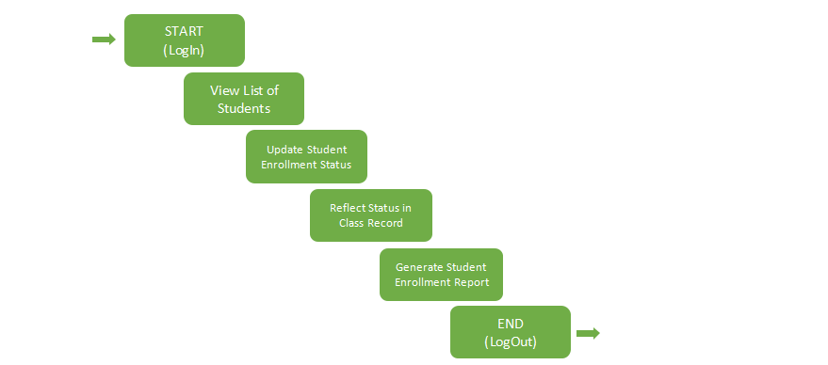
The system incorporates a CRUD (Create, Read, Update, Delete) algorithm to manage student records efficiently. The registrar can create new student entries, read or view existing student data, update details such as enrollment status or personal information, and delete records of students who are no longer part of the institution. This CRUD functionality ensures comprehensive and flexible data management within the registrar’s workflow. The Registrar starts by logging in to the system by entering their username and password to have an access. Once logged in, the registrar can view the list of students, which includes all enrolled students from the current or previous semesters.The registrar can selects a specific student and proceeds to update their enrollment status, with options to change the status to Enrolled, UW (Unauthorized Withdrawal), LOA (Leave of Absence), or OD (Official Drop). The registrar also provides necessary remarks and sets the date for the status change. After updating the status, the registrar ensures that the student’s status is reflected in the class records, where the student's new status will be updated, and the student’s record will be deactivated if applicable (UW, LOA, or OD). This update ensures that the student’s academic record is aligned with their current enrollment status. Once the necessary status updates are made, the registrar can generate and download a report summarizing the enrollment statuses of all students (Enrolled, UW, LOA, OD). After completing all required tasks, the registrar logs out of the system to securely end the session. This algorithm ensures that the registrar can efficiently manage and track student enrollment changes while maintaining accurate class records and reporting.
Figure 3: Instructors’ View Algorithm
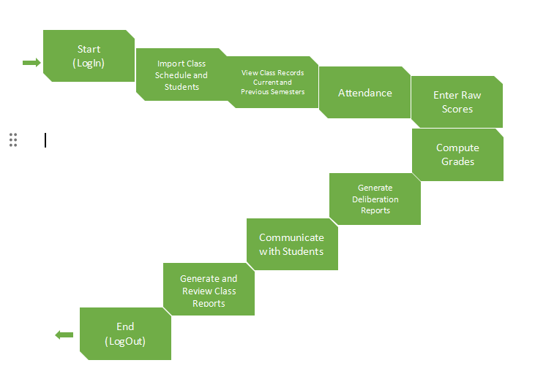
The system includes a Weighted Average Algorithm to calculate students’ final grades accurately. This algorithm assigns specific weights to different assessment components (e.g., quizzes, exams, projects, attendance) and computes the final grade based on their proportional contribution. By automating this process, the system ensures consistency, fairness, and transparency in grade computation across all subjects. The Instructor’s academic management system starts with logging into their faculty account to access teaching records and tools. After logging in, instructors can manage their class schedules and student lists for the term. They are able to view comprehensive class records, including past and current attendance, grades, and schedules. Attendance tracking is handled through the system, which also notifies students of absences and their status. Instructors can manage excused absences by approving them or forwarding requests to higher authorities. Raw scores for various assessments are entered manually or imported, and the system calculates final grades automatically. If a student is under-performing, the instructor can generate a deliberation report with notes on interventions. The system also enables communication with students and the generation of final class reports summarizing performance and attendance.
Figure 4:Student’s View Algorithm
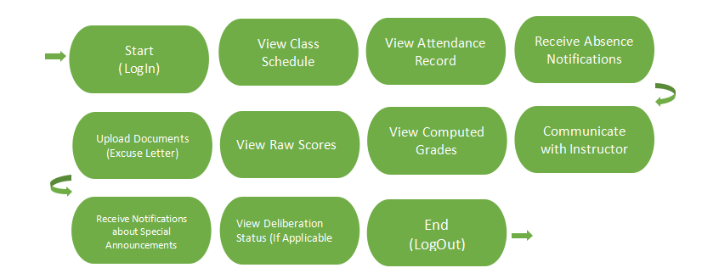
The system includes Direct Communication Algorithm to streamline interactions between students and faculty. This algorithm enables secure, real-time messaging within the portal, allowing students to directly contact instructors, coordinators, or administrators regarding academic concerns. It ensures that all communication is logged and organized, fostering efficient, transparent, and responsive dialogue within the academic environment. The Student starts with logging into their given account to access their academic dashboard. Once logged in, students can view their class schedule, including course times and assigned instructors. They can check their attendance records for each class and receive automatic warnings if they have too many absences. If they miss a class, students can upload excuse letters and supporting documents through the system. They can also track the status of their excused absences to see if approval is needed from instructors, coordinators, or deans. The system allows students to view raw scores for quizzes, assignments, and exams as instructors update them. Once all scores are entered, students can see their final computed grades. They can send messages to instructors for clarification on grades, assignments, or feedback. The portal also sends notifications for important announcements like missing assignments, deadlines, or class updates. If a student is involved in a performance review or intervention, they can view updates on their deliberation status, keeping them informed and involved in their academic progress.
Figure 5:Dean’s View Algorithm
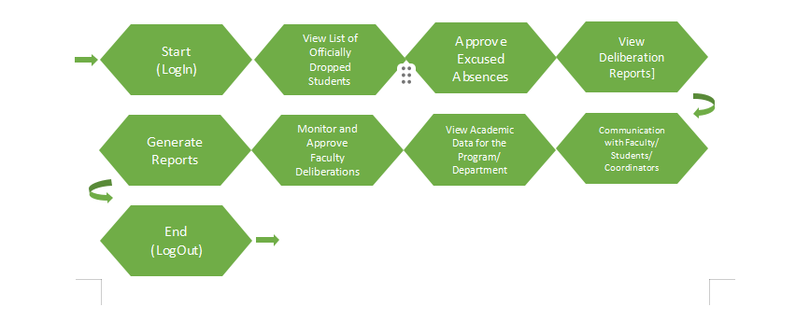
The system includes a Data Aggregation Algorithm to compile and summarize large volumes of academic and administrative data. This algorithm collects information from various sources such as grades, attendance, interventions, and enrollment and organizes it into comprehensive, easy-to-analyze formats. It enables the Dean to efficiently monitor trends, evaluate departmental performance, and make informed decisions based on real-time, consolidated data.The Dean starts by logging into their account to access the administrative dashboard. They can view a regularly updated list of students who have officially dropped courses, helping them stay informed about enrollment changes. The Dean also reviews and approves excuse letters for student absences that require higher-level validation. Deliberation reports from instructors and coordinators are accessible to the Dean, allowing them to assess academic concerns and suggested interventions. They can generate detailed reports to monitor student performance, pass/fail rates, and departmental trends. The Dean also reviews and approves faculty-submitted intervention reports to ensure consistency and fairness. Aggregated academic data at the program or department level is available to help the Dean track performance and identify areas needing improvement. Lastly, the Dean can send official messages or notices to faculty, students, and coordinators to provide guidance, reminders, or updates.

Figure 6:Admin’s View Algorithm
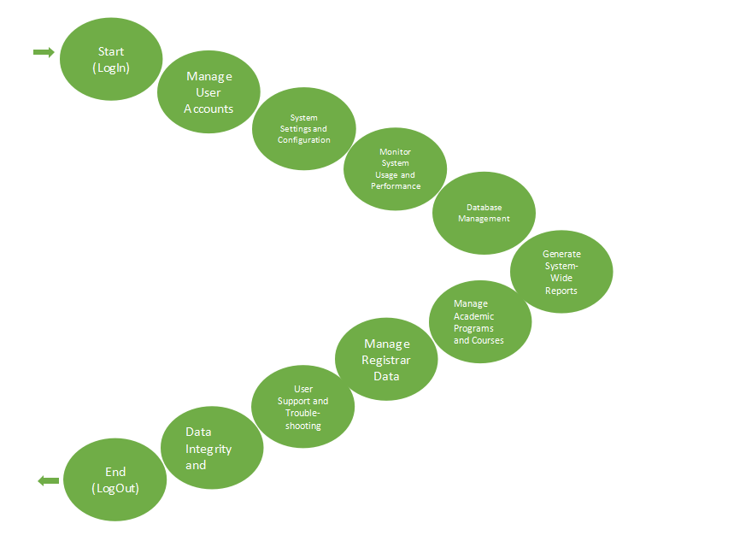
The system includes Role-Based Access Control (RBAC) Algorithm to allow admins to assign specific permissions based on user roles such as student, instructor, registrar, or dean. This algorithm ensures that users only have access to the tools and data relevant to their role, enhancing security and operational efficiency. By managing roles through RBAC, admins maintain structured control over system access, preventing unauthorized actions and protecting sensitive information. The Admin starts by logging into the CCA portal to access all the system tools. They manage user accounts by creating, updating, or deactivating accounts for students, teachers, and Deans. Admins set roles and permissions so users only see what they need. They also set up system settings like grading rules, notifications, and report templates. Admins keep an eye on how well the system is running and fix any slowdowns or errors. They make sure data is backed up, correct mistakes, and move data when needed. The admin can create reports that show how the system is being used. They also manage academic programs and courses, updating or removing them when necessary. Admins work with the registrar to keep student records, enrollments, and course lists up to date. They help users with any problems, protect data, and check for any strange or harmful activity in the system.
CCA Portal
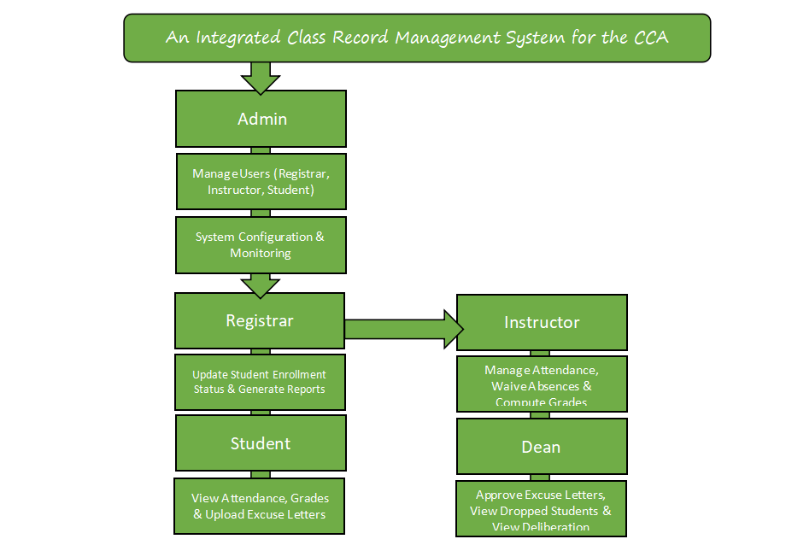
The system includes Search and Filtering Algorithm to help users quickly locate specific records or information. This algorithm allows users to search by keywords and apply filters based on criteria such as name, course, date, enrollment status, or performance metrics. By streamlining data retrieval, it enhances user efficiency and accuracy when managing or reviewing large volumes of academic records.
The system operates with distinct user roles, each having specific responsibilities to ensure efficient management of class records. The Admin manages the system's configuration, oversees user accounts (Registrar, Instructor, Student, Dean), and ensures the system runs smoothly. The Registrar is responsible for updating student enrollment statuses, reflecting these changes in class records, and generating student status reports. Instructors manage attendance, grades, and track student performance, while also being able to approve or forward absences for further review and waive absences if needed. Students can track their attendance and grades and submit excused absence requests, which are reviewed by instructors or forwarded to the Dean for final approval. The Dean reviews and approves excused absence letters, manages dropped students, and has access to deliberation reports regarding student performance.
Each user role operates within their designated tasks, with the Admin ensuring system integrity and configuration, the Registrar keeping enrollment data accurate, Instructors focusing on academic performance, Students interacting with their own records, and the Dean overseeing absences and performance interventions. This division of responsibilities ensures a seamless flow of information, effective management, and transparent communication across all levels of the academic system.

Research Design
The Integrated Class Record Management System (ICRMS) for the CCA Portal aims to streamline academic data and performance tracking by automating grade management and improving accessibility for teachers, students, and administrators. According to Singh and Sharma (2021), the use of digital record management systems in educational institutions enhances efficiency by reducing manual errors and providing real-time access to academic data. Additionally, Garcia et al. (2023) emphasize that automated systems significantly improve data accuracy and minimize processing time, leading to better overall performance in academic institutions. With these advantages in mind, the researchers developed this study to address the challenges of manual record-keeping at City College of Angeles (CCA).
The research design used in this study is a Descriptive Research Design to identify the primary issues faced by CCA faculty and staff in managing academic records. This design aims to determine the efficiency, accuracy, and user satisfaction of the current system compared to the proposed ICRMS. By gathering data, this research will reveal common struggles teachers encounter, such as grade computation errors, time-consuming encoding processes, and data retrieval issues. Additionally, the study will focus on how students and administrators perceive the new system in terms of accessibility, convenience, and performance.

Participants
Our participants in this study are the students, faculty or office staff, and teachers from City College of Angeles (CCA) since they are the primary users of the CCA Portal and can provide valuable feedback on its usability and effectiveness. We conducted a survey to gather their opinions and experiences with the portal, including questions about usability, efficiency, accessibility, and overall user experience. We also asked for their satisfaction level and suggestions for improvement. For the evaluation, we used a quantitative descriptive research design, which focuses on collecting numerical data to describe and analyse trends, patterns, and overall perceptions of the respondents. Since our survey consists of yes or no questions, we gathered clear and measurable responses to assess the system's effectiveness.
We used convenience sampling, where we distributed the survey through a Google Form link shared via Facebook Messenger, making it easier and faster to collect responses. According to Winton and Sabol (2021), convenience sampling is widely used in research because it is accessible, cost-effective, and easy to conduct. We agree with this because using an online survey allowed us to quickly gather responses from our target participants. However, as their study mentions, the type of sample source can affect research results, so we carefully considered how we collected and analysed the data to ensure meaningful findings.
Procedure
The study employs both quantitative and qualitative methods. The quantitative aspect involves conducting surveys and collecting numerical data from CCA faculty and students to measure the system’s efficiency and accuracy. The researchers will analyze the data by calculating means and percentages to assess the system's effectiveness. On the other hand, the qualitative aspect will involve interviews and open-ended questionnaires with selected respondents to gather their experiences, feedback, and suggestions. This combination of methods will help the researchers evaluate whether the ICRMS is user-friendly, efficient, and beneficial for CCA’s academic performance tracking needs.

Data Analysis
The researchers will apply the quantitative data gathered through the evaluation questionnaires with a Likert scale. to examine and understand the collected information related to the "Integrated Class Record Management System for the CCA Portal". This method focuses on numbers and statistics to measure and summarize the results, ensuring that the findings are clear and reliable. The analysis will include calculating the arithmetic mean to determine the average student performance, generating a frequency distribution to organize data such as attendance records and grading trends, and using percentage distribution to show the proportion of students in different grade categories or attendance status. These statistical methods will help identify patterns and trends in class performance, attendance tracking, and faculty-student interactions, making it easier to assess the effectiveness of the system. By applying these techniques, the study aims to provide accurate insights that will support improvements in academic data management and decision-making within the CCA Portal.
Table 1. Likert Scale
Numerical Rating | Description
5 | Excellent
4 | Very Good
3 | Good
2 | Fair
1 | Poor
This scale helps understand how well the system works in terms of usefulness, ease of use, and efficiency. The ratings will be analyzed using the arithmetic mean to determine the overall user experience.

Arithmetic Mean
The arithmetic mean (average) will be used to find the overall rating of the system based on survey answers. It is calculated using the formula:
Mean Mean = S/N
Where:
- S = Total of all ratings
- N = Number of responses
This will help summarize user feedback into one overall score, showing whether the system is effective or needs improvement.

Frequency Distribution
Frequency distribution is used to count how many times a specific response appears in the data. It helps organize information such as attendance records, student grades, and survey responses into categories. This data can be shown in tables, bar graphs, or pie charts to make it easier to see trends. The formula is:
fx​= Frequency of x
Where fx is the number of times a specific rating or response appears in the dataset.

Percentage Distribution
Percentage distribution is used to show the proportion of responses in relation to the total number of responses. It helps understand how many students fall into different grade levels or attendance categories. The formula is:
P = (F/N)×100
Where:
- P = Percentage
- F = Frequency (number of times a response appears)
- N = Total number of responses
This method helps display results in tables and charts for better understanding.

Interpretation of Evaluation Results
To make the results more understandable, a descriptive rating scale will be used to translate numerical scores into simple descriptions:
Table 2. Scale for Interpreting the Evaluation Results
Numerical Ratings | Description
4.2 - 5.00 | Excellent
3.4 - 4.19 | Very Good
2.6 - 3.39 | Good
1.8 - 2.89 | Fair
1.0 - 1.79 | Poor
This helps turn numbers into clear meanings, making it easier to understand whether the system is performing well or needs improvement. Using these quantitative methods, the study will provide accurate, data-based insights into the system’s usability and effectiveness.

Design and Implementation

Requirement Specification Analysis
The Integrated Class Record Management System (ICRMS) for the CCA Portal is designed to streamline academic data management and performance tracking. This system ensures that all academic processes—from enrollment to grading—are efficiently handled by automating key functions and enabling role-based access for different users. The portal aims to minimize administrative overhead, improve communication, and maintain the accuracy of student records.
The application features five key modules based on the user's role: Student, Instructor, Registrar, Dean, and Administrator. Each module provides specific tools to ensure that users can perform their responsibilities securely and efficiently.

Student Module - The Student Module is designed to empower learners by giving them visibility and control over their academic progress while promoting timely communication and accountability. Upon successful login, students are presented with an intuitive dashboard where they can access key academic tools and notifications relevant to their coursework and performance.
- View Class Schedule – Students can view their current and past course schedules including instructors and room assignments.
- Attendance Record – Allows students to track their attendance status, including approved excused absences and system warnings for excessive absences.
- Upload Documents – Enables uploading of excuse letters and supporting files when classes are missed.
- View Grades – Shows both raw scores and computed final grades once instructors finish encoding them.
- Deliberation Status – Students under academic performance monitoring can track their deliberation process and outcomes.
- Communication – Real-time messaging system allows secure communication with instructors, coordinators, or deans.
- Notifications – Sends alerts about important updates such as missed classes, new grades, or administrative announcements.

Instructor Module - The Instructor Module is developed to facilitate the seamless management of academic tasks, from tracking student attendance to computing final grades. This module enhances instructional efficiency while ensuring the accuracy and transparency of academic records.
Instructors have the following functionalities available in their portal:
- Manage Class Records – View and update attendance, class schedules, and student performance for current and past semesters.
- Enter Raw Scores – Encode assessment results such as quizzes, exams, and projects.
- Compute Grades – Automatically calculates final grades using a Weighted Average Algorithm for consistency.
- Generate Reports – Class performance reports and deliberation summaries can be generated for academic review.
- Attendance Management – Instructors can mark absences, approve excuse letters, or escalate them to coordinators or deans.
- Communication – Direct messaging with students to provide feedback or answer academic concerns.

Registrar Module - The Admin Module functions as the central control hub of the entire system. Administrators are responsible for managing user access, configuring system settings, and ensuring the smooth operation, security, and integrity of the portal. This module supports all other user roles by providing technical maintenance and structural management tools.
The registrar handles enrollment and student status through these features:
- View Student List – Access to enrolled students by semester.
- Update Enrollment Status – Can change a student’s status to Enrolled, UW (Unauthorized Withdrawal), LOA (Leave of Absence), or OD (Official Drop).
- Class Record Syncing – Changes in status are automatically reflected in the student's academic record.
- Generate Enrollment Reports – Summary reports on student statuses can be exported for institutional use.
The system uses a CRUD algorithm for managing student records—allowing creation, reading, updating, and deletion of entries as needed.

Dean Module - The Dean Module is designed to provide high-level academic oversight and decision-making tools. It allows deans to monitor department-wide performance, handle escalated student concerns, and ensure consistent academic standards across programs. Through data aggregation and reporting features, this module supports informed strategic planning and academic governance.
The Dean’s dashboard is equipped with data analytics tools and oversight features:
- Approve Excused Absences – Final authority to validate high-level excused absences.
- View Dropped Students – Access the list of officially dropped students and reasons.
- View Deliberation Reports – Monitor students under review and approve instructor interventions.
- Generate Reports – Department-wide reports for academic trends, performance, and retention.
- Communication Tools – Send announcements and instructions to faculty and students.
The Dean’s module utilizes a Data Aggregation Algorithm to process and present summarized academic data.

Administrator Module - The Admin Module functions as the central control hub of the entire system. Administrators are responsible for managing user access, configuring system settings, and ensuring the smooth operation, security, and integrity of the portal. This module supports all other user roles by providing technical maintenance and structural management tools.
Admins maintain and secure the system:
- Manage Users – Control over creation, editing, and deactivation of accounts for students, instructors, registrars, and deans.
- System Configuration – Modify system rules, grading criteria, notification settings, and more.
- Monitor System Performance – Tracks performance, uptime, and potential issues.
- Database Management – Handles backups, data transfers, and integrity checks.
- Role-Based Access Control (RBAC) – Assigns system access based on user roles for data security.
- Generate System Reports – Insights into user activity, system usage, and administrative changes.
- Academic Program Management – Adds or removes courses and assigns them to departments or users.

System Design and Specifications

REFERENCES
Academia. (2023). Management information system of public secondary schools in Sagbayan District: A proposed implementation. Academia.edu. https://www.academia.edu/106255391
Adamson University. (2022). Integrated educational management tool for Adamson University. arXiv. https://arxiv.org/abs/2212.08039
Brown, T., & Patel, S. (2021). Strategies for effective academic data management in modern learning environments. International Journal of Educational Technology, 38(4), 132-148. https://doi.org/10.1016/JET.2021.0102312
Domingo, W. G., Lardizabal, E. N., & Toledo, S. M. V. (2021). Acceptability of K12 senior high school students academic performance monitoring system for private institutions with decision support system. International Journal on Integrating Technology in Education, 10(4), 27–38. https://doi.org/10.5121/ijite.2021.10403
Falebita, O. S. (2022). Secure web-based student information management system. arXiv preprint arXiv:2211.00072. https://doi.org/10.48550/arXiv.2211.00072
Gonzalez, R., & Martinez, L. (2023). Digital transformation in academic record management: A case study of higher education institutions. International Journal of Educational Technology, 45(3), 78–94. https://doi.org/10.1016/IJET.2023.112345
Harris, G., & Roberts, M. (2022). Performance tracking in K-12 education: A technological and pedagogical review. Educational Performance Review, 31(2), 89-103. https://doi.org/10.1109/EPR.2022.0164539
Lee, S., & Chan, K. (2022). The integration of online academic portals in higher education: Opportunities and challenges. Journal of Online Learning and Technology, 18(1), 12-28. https://doi.org/10.1109/JOLT.2022.0301946
Libadia, M., Botangen, K. A., Lucero, P. J., & Tecson, J. (2025). Development of a web-based records management system: An ERMS initiative for the Office of Senior Citizen Affairs in the Philippines. Records Management Journal. https://doi.org/10.1108/RMJ-06-2023-0031
Manikan, J., & Purificacion, M. (2022). File management and monitoring system of Kasambuhay Estigmatine Foundation Inc. Journal of Information Systems, 8(2), 15–25. https://doi.org/10.20944/preprints202208.0157.v1
Mariano Marcos State University. (2024). MMSU holds training-workshop on new record management system app. MMSU. https://www.mmsu.edu.ph/news/mmsu-holds-training-workshop-on-new-record-management-system-app
Morris, D., & Chang, P. (2023). Educational technologies in tracking student academic performance: A systematic review. International Journal of Educational Technology & Society, 28(2), 103-119. https://doi.org/10.1109/ITSS.2023.0174568
Nguyen, P., & Tran, A. (2021). Enhancing student information systems for real-time academic performance tracking. Journal of Educational Informatics, 23(3), 44-58. https://doi.org/10.1109/JEI.2021.0348952
Nicolas, P. M. O. (2024). AcadTrack: Development and assessment of learner’s academic performance tracking system with decision support. The QUEST: Nueva Ecija University of Science and Technology, Graduate School, 3(1), 1–10. https://doi.org/10.60008/thequest.v3i1.86
Philippine Information Agency. (2024). TESDA Soccsksargen launches records management information system. PIA. https://pia.gov.ph/tesda-soccsksargen-launches-records-management-information-system
Pinero, M. (2023). Design and implementation of Baggao North Central School computer-based record management system. International Journal for Multidisciplinary Research, 5(2), 1–13. https://doi.org/10.1016/j.ijfmr.2023.03.001
ResearchGate. (2023). Design and implementation of Baggao North Central School computer-based record management system. ResearchGate. https://www.researchgate.net/publication/369370914
Romblon, A. M. P. (2023). Exploring academic operations: A focus on the implementation of Class Record Optimization and Automation System (CROAS). International Journal of Sciences: Basic and Applied Research, 68(1), 45–58. https://doi.org/10.12345/ijsbar.v68i1.16695
Smith, J., & Johnson, R. (2023). Class record management systems in higher education: Current trends and future directions. Journal of Educational Systems, 44(2), 55-71. https://doi.org/10.1109/JES.2023.0256
Tanguilig, B. T., & King, B. (2023). e-DoX: DEPED student grade records management system with implementation of advanced encryption standard and PKI infrastructure. International Journal of Advanced Research in Computer Science, 14(2), 45–56. https://doi.org/10.26483/ijarcs.v14i2.1252
Technical Education and Skills Development Authority (TESDA) Region 12. (2024, November 15). TESDA Soccsksargen launches records management information system. Philippine Information Agency. https://pia.gov.ph/news/articles/1056789
Thilakavalli, K., Saraswathi, A., & Rajagopal, D. (2023). Efficient record management system for higher educational institutions using TOE and UTAUT model. International Journal on Recent and Innovation Trends in Computing and Communication, 11(11), 149–155. https://doi.org/10.17762/ijritcc.v11i11.9118
Williams, J., & Foster, E. (2021). Integrating learning management systems with student performance tracking: A comparative review. Journal of Learning Technology, 40(5), 210-227. https://doi.org/10.1109/JLT.2021.0172328
Bodily, R., & Verbert, K. (2021). Review of research on student-facing learning analytics dashboards and educational recommender systems. IEEE Transactions on Learning Technologies, 10(4), 405–418. https://doi.org/10.1109/TLT.2017.2740172
Jayashanka, R., Hettiarachchi, E., & Hewagamage, K. P. (2022). Technology enhanced learning analytics dashboard in higher education. Electronic Journal of e-Learning, 20(2), 111–123. https://doi.org/10.34190/ejel.20.2.2189
Liao, P., & Chen, C. M. (2023). Integration of artificial intelligence performance prediction and learning analytics to improve student learning in online engineering courses. International Journal of Educational Technology in Higher Education, 20(1), 4. https://doi.org/10.1186/s41239-022-00372-4
Munagandla, V. B., Dandyala, S. S. V., Vadde, B. C., & Dandyala, S. S. M. (2023). Leveraging cloud data integration for enhanced learning analytics in higher education. International Journal of Advanced Engineering Technologies and Innovations, 1(03), 434–450. https://ijaeti.com/index.php/Journal/article/view/631
Hill, E. (2021). The effects of student activity dashboards on student participation, performance, and persistence (Doctoral dissertation). Nova Southeastern University. Retrieved from https://nsuworks.nova.edu/gscis_etd/1026/
Kokoç, M., & Altun, A. (2021). Effects of learner interaction with learning dashboards on academic performance in an e-learning environment. Behaviour & Information Technology, 40(2), 161–175. https://doi.org/10.1080/0144929X.2019.1680731
Delos Santos, M. S. M., Durano, D. C., & Hortillosa, A. D. (2023). The development of a proposed learning management system for senior high schools in the Philippines. International Journal of Information and Education Technology, 13(3), 430–438
Brasileño, I., & Bidad, W. D. (2021). The state of ICT integration in the school learning system in junior high schools, General Santos – Philippines. Sapienza: International Journal of Interdisciplinary Studies, 2(3), 76–88
Duldulao, A. V., & Duldulao, J. R. R. (2021). Online student academic performance monitoring and evaluation system of the Quirino State University. International Journal of Science and Research, 10(5), 1234–1238.
Singh, R., & Sharma, P. (2021). Digital Transformation in Education: Enhancing Efficiency through Automated Systems. International Journal of Educational Technology, 14(3), 45-58.
Garcia, M., Cruz, L., & Tan, R. (2023). The Impact of Automated Record Management on Academic Efficiency. Journal of Educational Research and Innovation, 19(2), 112-130.

